Spring Pre- requisites:-

1. Core Java
2. Adv Java(JDBC, Servlet & JSP)
3. SQL Basics (DML & DDL)

Course Content:-

**Part-1:-**

1. Introduction of Spring Framework
2. Evolution Spring
3. Advantages of Spring Framework
4. Spring Architecture
5. Spring Versions
6. Spring Core Module
7. IOC Container
8. Dependency Injection

-Constructor Injection

-Setter Injection

- Aware Interface Injection

- Method Injection

9. Bean Inheritance

10 Collection Merging

11. Bean Aliases

12. Bean Ref

13. Factory Methods

-Static Factory

- Instance Factory

14. Bean Scopes

15. Bean wiring

-Manual wiring

- Autowiring

16. Nested Bean Factories

17 . Bean Life Cycle

18 . P & C Name Spaces

19. Spring Annotations.

20 Bean Post Processors

21. Bean Factory Processor

22. Working with Properties Files

23. Property Editors

--------------------------------------------------------------------------------------------------------------------------------------------------------------------------------------------------------------------------------------------------------------

**Part 2:- Spring AOP(Aspect Oriented Programming)**

1. AOP Introduction
2. Proxy Design Pattern
3. Aspect
4. Target
5. Weaving
6. JointPoint
7. PointCut
8. Before Advice
9. After Advice
10. After Returning Advice
11. Around Advice
12. Throws Advice

**Part 3:- Spring DAO Module**

1. Introduction of Persistence Layer
2. Best Practices
3. Spring JDBC Introduction
4. DataSource
5. JDBCTemplate
6. NamedParameterJdbcTemplate
7. SimpleJdbcCall
8. JDBC Insert
9. Working with Annotations

**Part 4:- Spring MVC**

1. MVC Introduction
2. FrontController Design Pattern
3. Spring Web MVC Advantages
4. DispatcherServlet
5. Handler Mapper
6. Controller
7. ViewResolver
8. View
9. Interceptors
10. CurdOperations

**Part 5:- Spring ORM**

1. ORM Basics
2. Entity class
3. How to Map Java Class with DB Table
4. Hibernate Template
5. CallBack Interfaces

**Part 6:- Spring Security**

1. Spring Security Introduction
2. Authentication
3. Autherization
4. FilterProxy

* Form Login
* Default

1. Secure the Application by using Annotations

**08-03-2021**

Spring Technology involve into Several modules: Spring is a framework to build an end to end application. It reduces the boiler plate coding.

Framework is a semi developed common logics

Two types of Frameworks are available in java

1. Web Framework -- Struts
2. ORM Framework - Hibernate

Spring is an application development framework.

An application consists of multiple layers.

1. Application Layer
2. Web Layer
3. Service Layer
4. Persistance Layer
5. DataBase.

Spring is not a single Framework it is a collection of Frameworks. Spring Framework is developed in modular fashion.

1. Spring Core
2. Spring Context
3. Spring AOP
4. Spring DAO
5. Spring Web MVC
6. Spring ORM

Framework:- Framework is nothing the some logic build to work on the multiple applications.

There are two frameworks are available

1. ORM Framework-- Hiberante
2. Web Framework--- Struts

Spring is an Application Development Framework.

By using spring framework we can develop end to end Application.

Spring is an versatile Framework—We can develop struts framework Web layer and Spring can be integrated with any java framework which is available in market.

Spring is an Non Invasive Framework:- It will not force you the developer to extend or any framework.

Spring is loosely coupled Framework:- Spring is a collection of framework. Modular Framework

1. Core Module
2. Spring Context
3. Spring AOP
4. Spring DAO
5. Web MVC
6. Spring ORM

**Spring Core Module**:- It is a base module for spring framework. This module providing fundamental concepts of Spring they are IOC and DI.

IOC:- Inversion of Control

DI:- Dependency Injection.

**Spring Context Module**:- It will take care of Configurations required in our application.

**Spring AOP(Aspect Oriencted Programming)** :- It separates Business logic and secondary logic in application.

Fetching data from DB and display on UI is nothing but a business logic and Secondary logic is nothing but a Helper logic tx, Security, Logging and auditing.

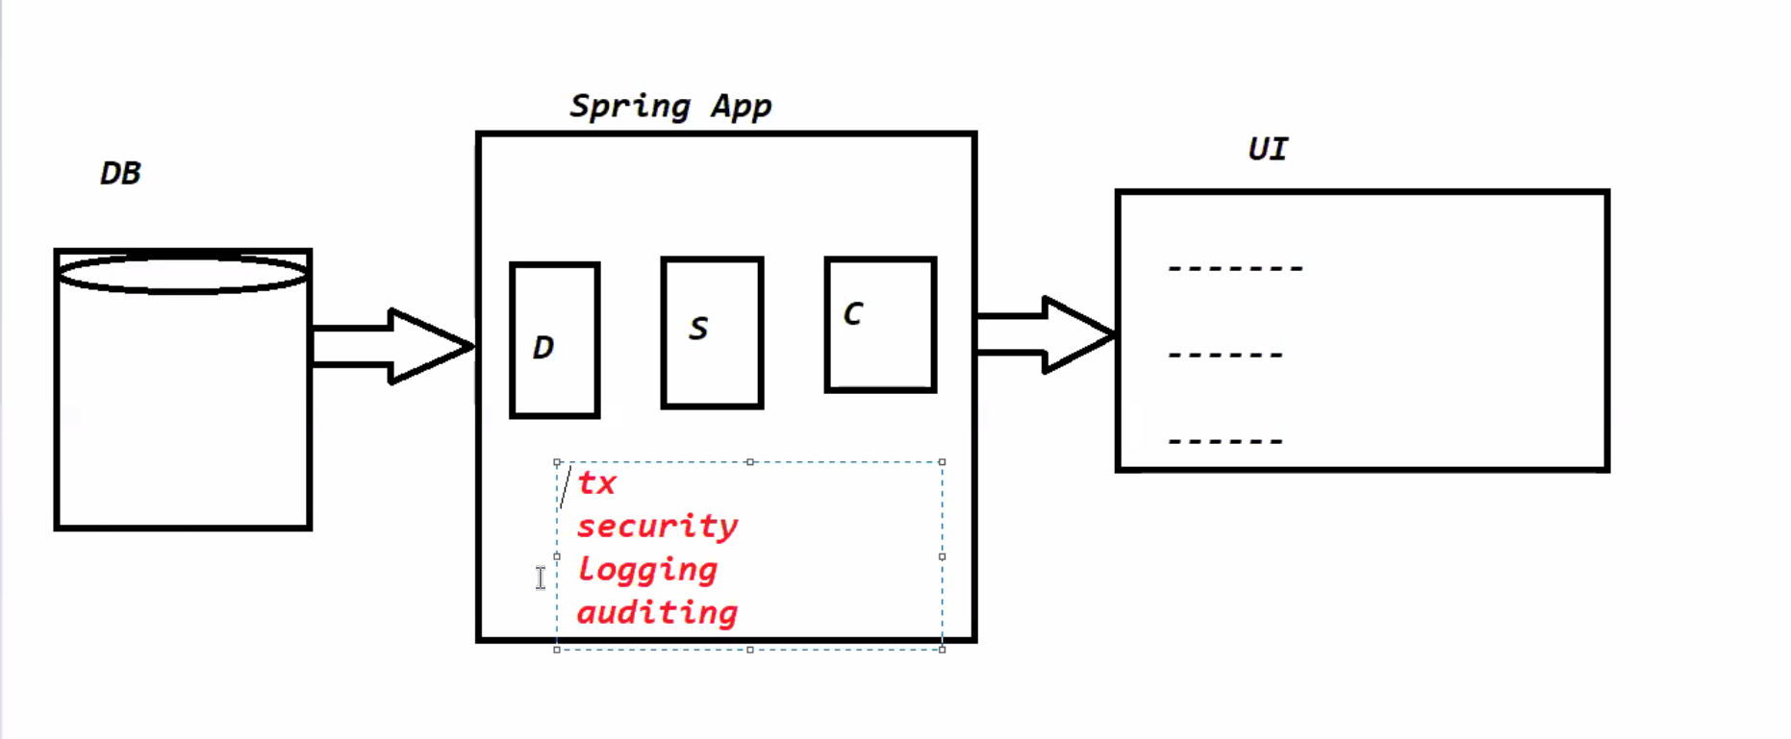

**Spring DAO(Spring JDBC)**:-Spring DAO is used to develop the persistence layer.

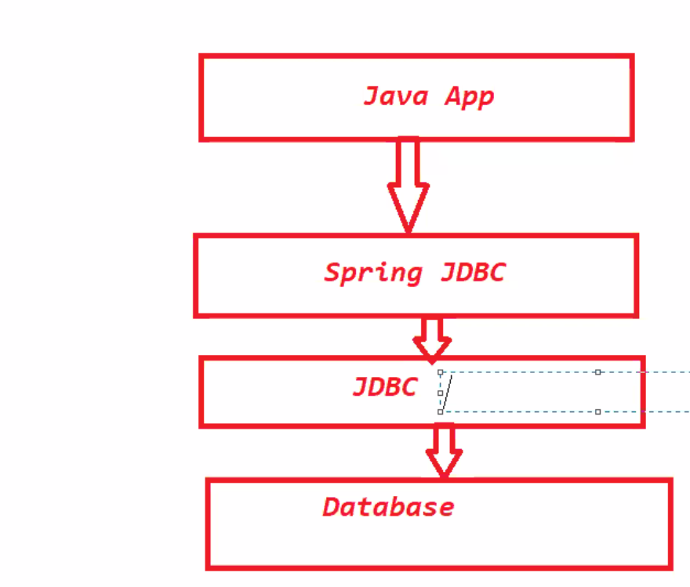

**Spring Web MVC**:- Spring Web MVC is used to develop the Web Applications and distributed applications . It is developed on top of Servlets.

Web Applications:- Gmail,

Distributed Applications:- Webservices.

**Spring ORM Module:-** It is used to develop the Persistence Layer

ORM:- Object Relational Module

It is used to represent the data in the form of object:-

**09-03-2021**

**Spring Framework Version History:-**

Spring Framework is developed by Rod Johnson

2002 – 0.9 version

2004 -1.0 Version(First production Release)

2006- 0.2

2009- 0.3

2013- 0.4

2017 – 0.5

**Spring 1.x Version:-**

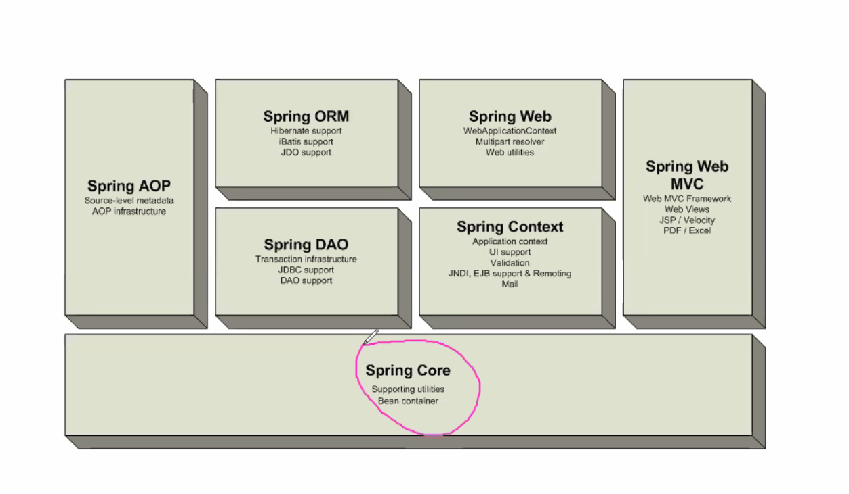

Spring Web and Spring Web MVC are two different modules in Spring 1.x Version. Total 7 modules

**Spring 2.x Version:-**

Spring Web and Web MVC is combined into one module 6 modules are available

**Spring 3.x Version:-** They are categorized one module into multiple modules.

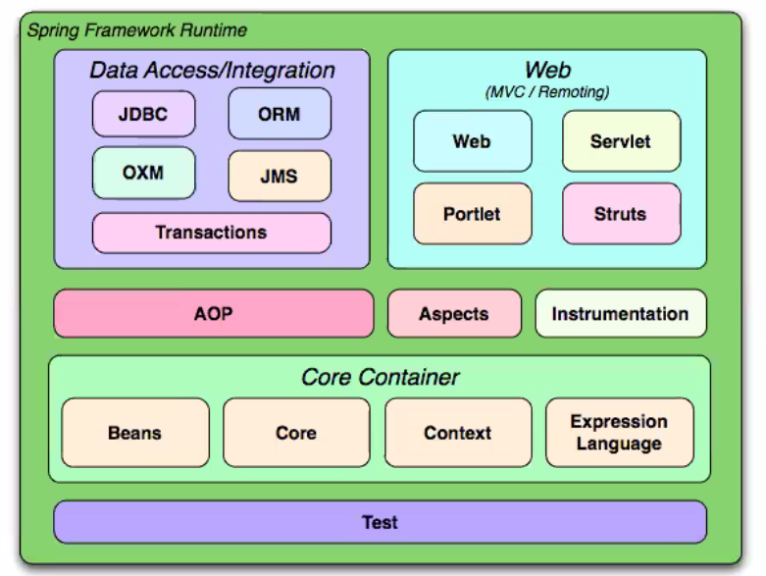

**Core Module is divided into 4 modules:-**

1. Beans
2. Core
3. Context
4. Expression Language

Junit is used to test the application Test Module.

**Spring 4.x Version:-** Messaging concept is added in Spring 4.x

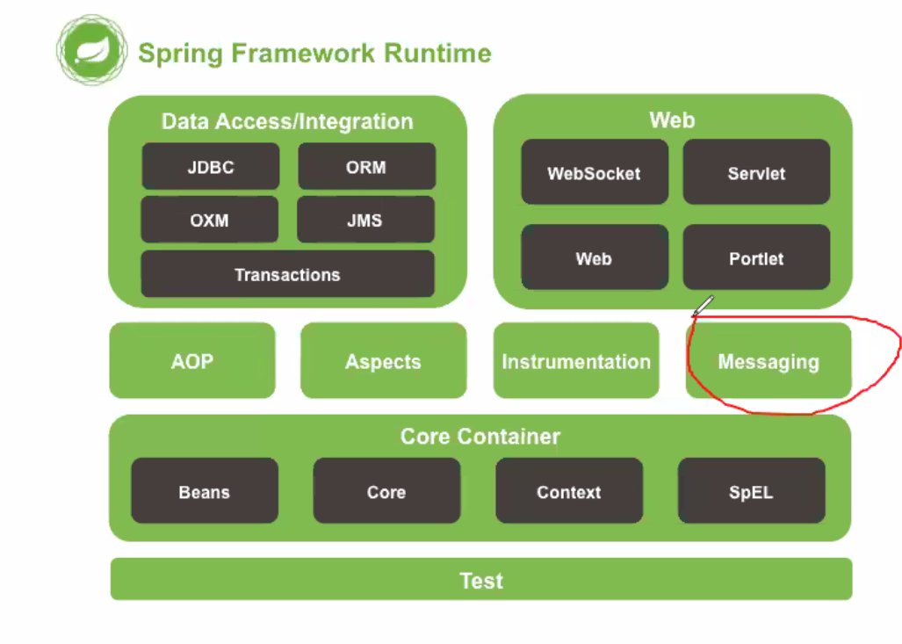

**Spring 5.x Version:-** No change in the Modules

Reactive Programming support is added

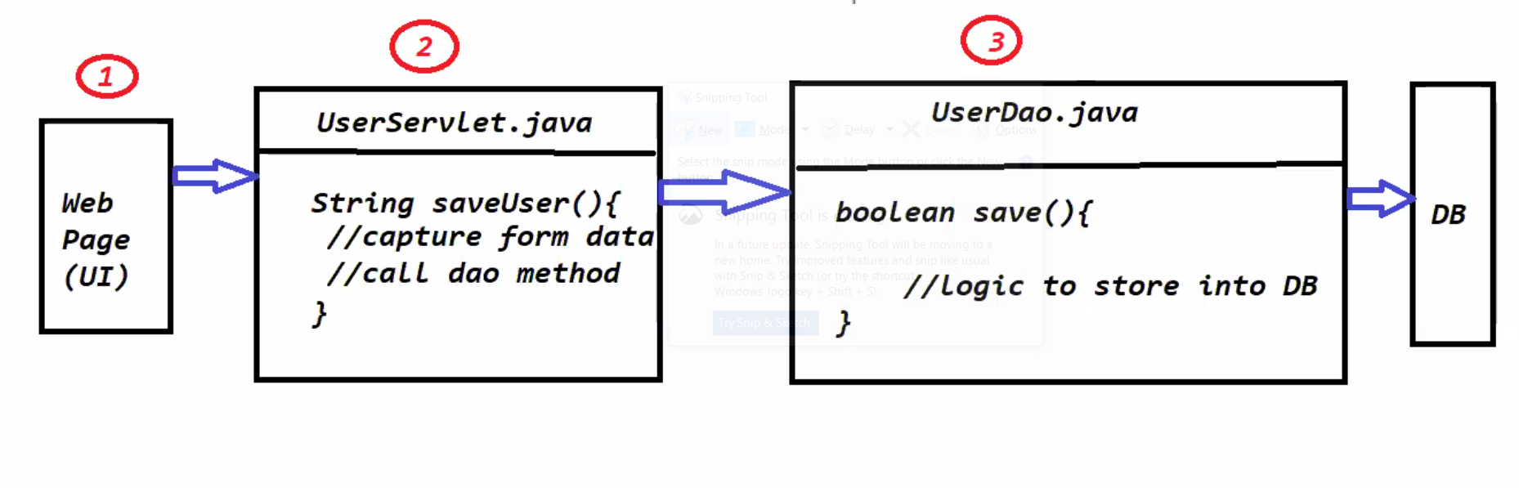

**11-03-2021**

**Spring Core Module:-** Develop User Registration Form using Layered Architecture.

1. Presentation Layer (UI)
2. Web Layer (Request Handler)
3. Service Layer (Business Logic)
4. Persistence Layer. (Database)

**12-03-2021**

**Design Patterns :-** Design Patterns are used to represent some of the best practices to solve common problems in Applications Development.

We can see 3 types of Design Patterns

1. Creational Design Patterns:- It talks about the Creation of an Instance. (Obj Creation)
2. Structural Design patterns:- How to glue the Component in the applications efficiently. (flexibility)
3. Behavioral Design Patterns:- Abstract an action (Change the Algorithm in runtime). Without changing the code how to switch one algorithm to another algorithm.

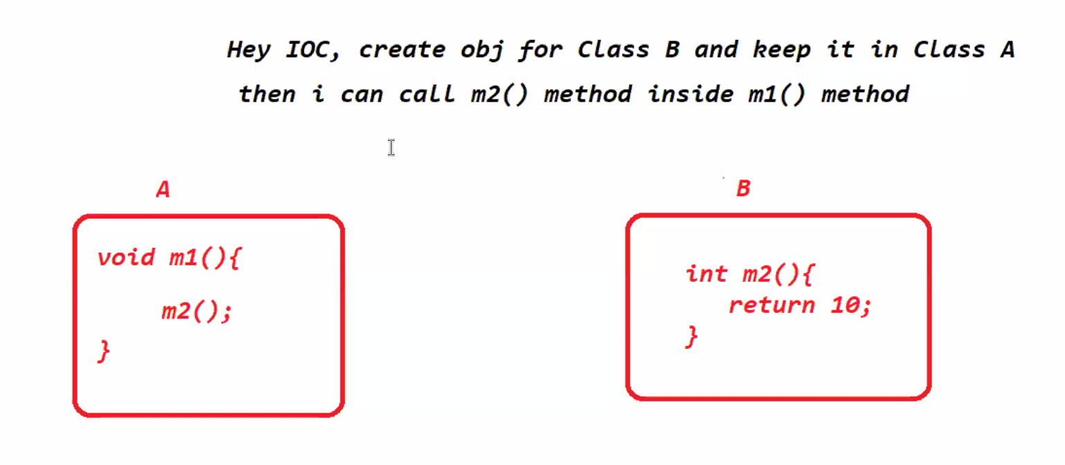

Strategy Design Pattern rules:-

1. Code Should be open for extension and closed for Modification
2. Always code to interfaces instead of concreate implementations
3. Favour Composition over Inheritance.

**15-Mar-2021**

Spring framework suggested to follow the Strategy design pattern while developing classes to achieve loosely coupling.

If we develop our classes by following strategy design pattern then we can ask IOC to provide the dependencies among our classes with loosely coupling.

Strategy Design pattern:- Using this strategy design pattern we can choose implementation or algorithm in the run time.

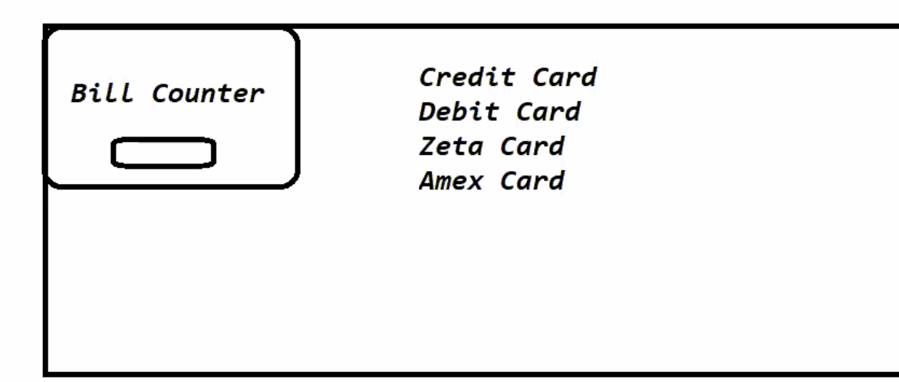

The algorithm should change based on the card at run time.

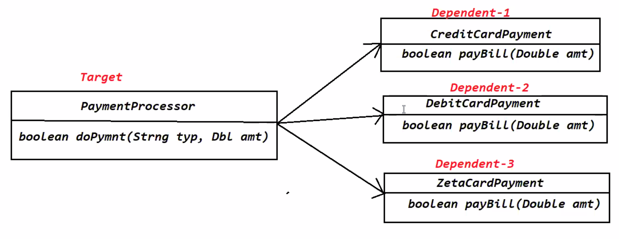

**17-Mar-2021**

**Constructor Injection**:- The process of injecting dependent class object into Target class object through Constructor is called constructor injection.

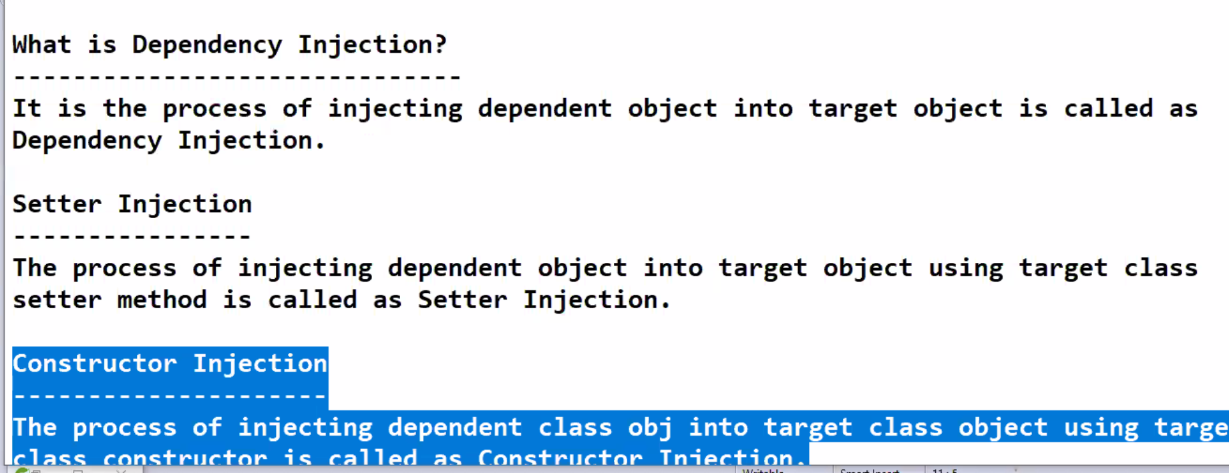

**18-Mar-2021**

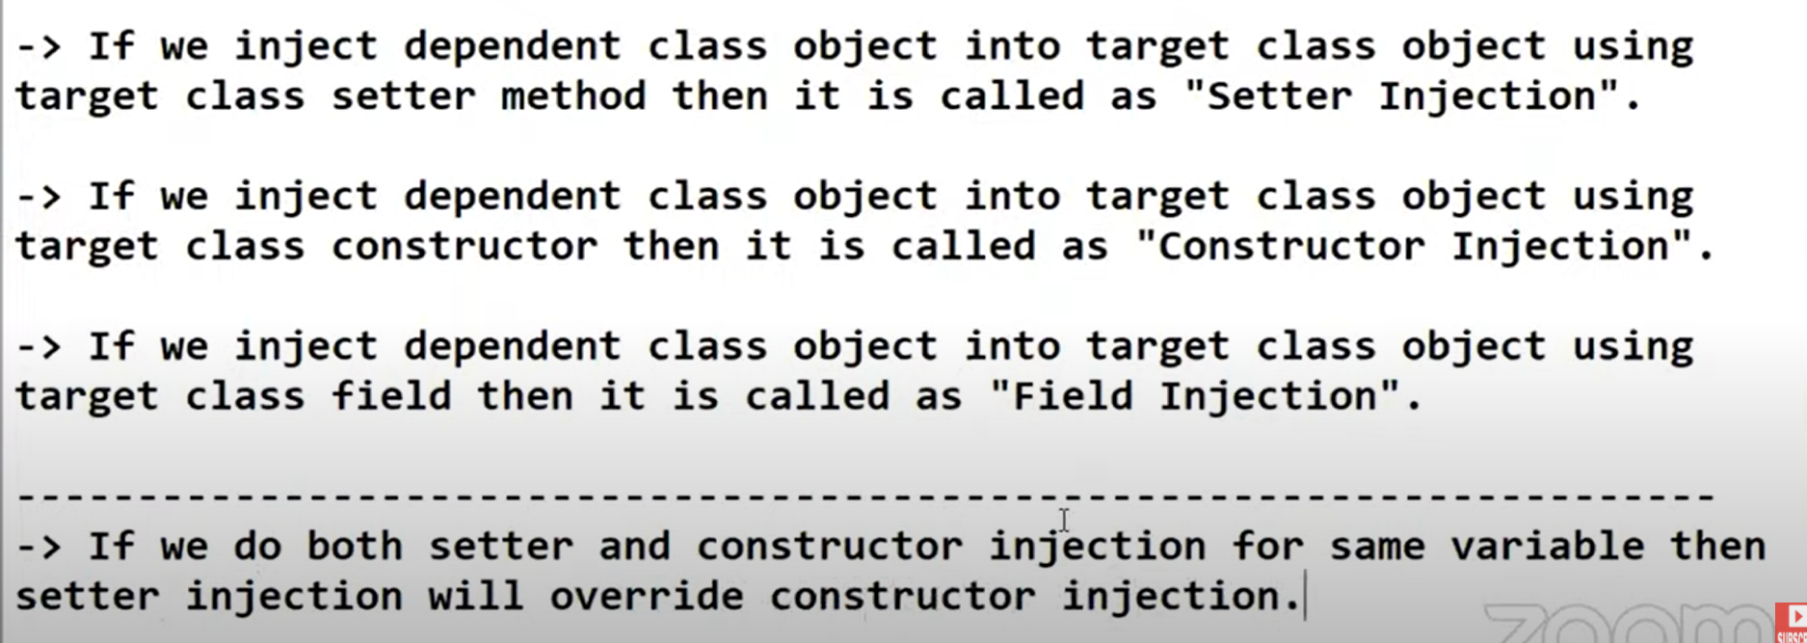

Field Injection, Setter Injection, Constructor Injection. If we use both constructor and setter injection setter injection will override the constructor injection.

**19-Mar-2021**

**IOC Container**:- IOC container is a principle which is used to manage and collaborate the dependencies among the object in an Application.

**Dependency Injection**:- The process of creating and injecting dependent class objects into Target class object is called dependency injection.

We can achieve Dependency injection. 1. Field, Setter and Constructor injection.

IOC Does not know my requirement.

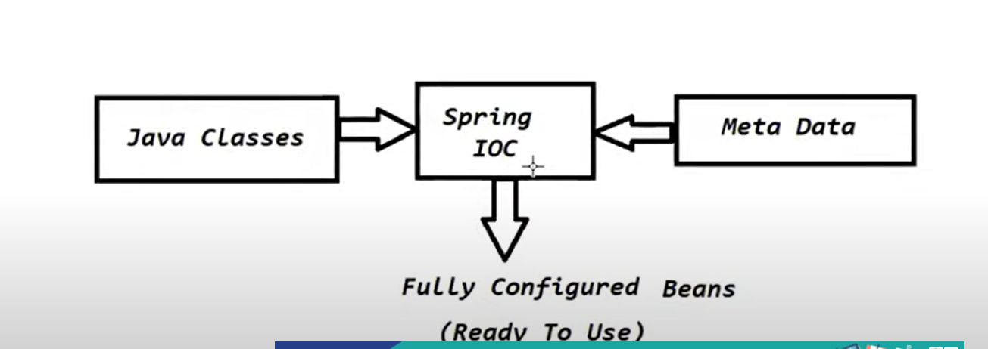

Steps to develop a Spring Application.

1. Create a maven project using quick-start-archetype
2. Add spring-context dependency in pom.xml
3. Create classes which are required by using Strategy Design pattern
4. Create Configuration file and Configure Bean definitions which will be used by IOC to perform DI
5. Start the IOC container and get the bean obj and test the application.

**23-Mar-2021**

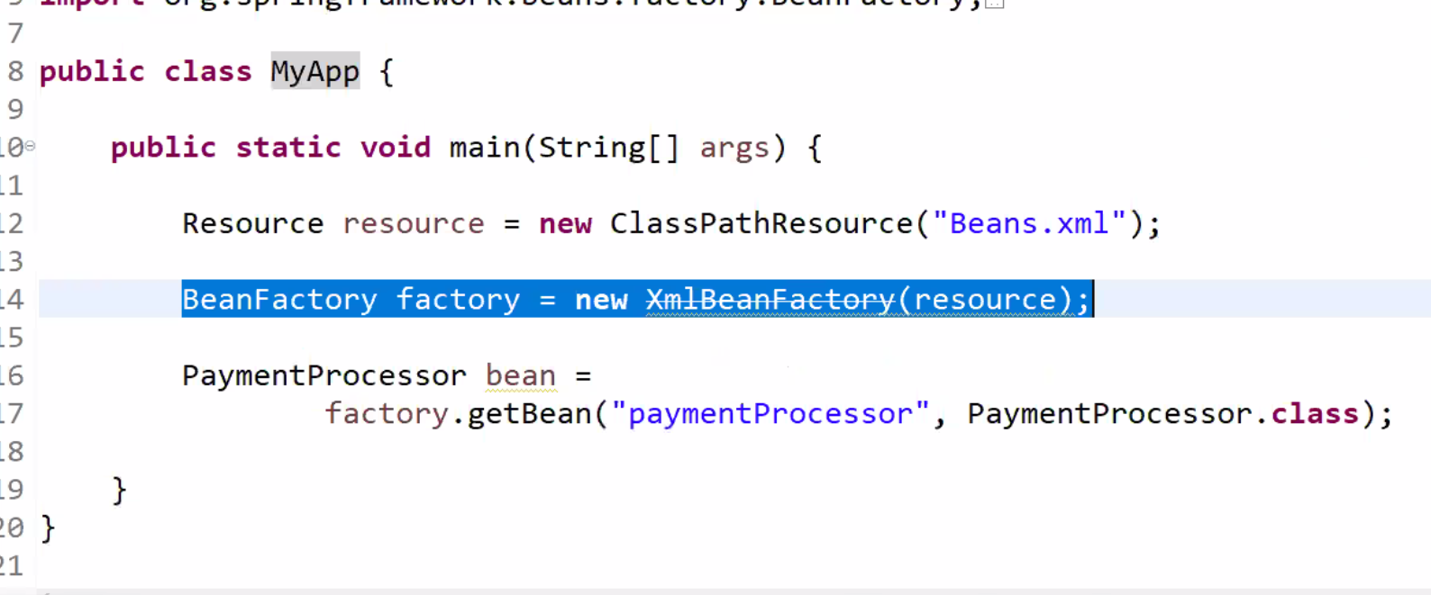

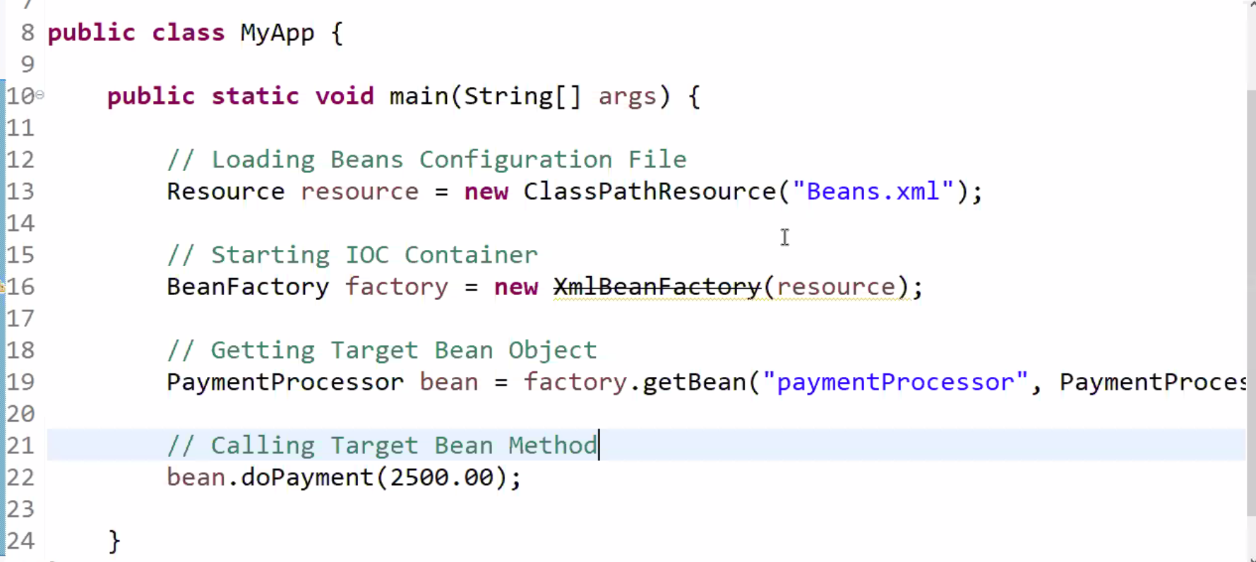

Resource resource=new ClassPathResource(“Beans.xml”);

and BeanFactory factory=new XMLBeanFactory(resource);

**Constructor injection:-**

<constructor-arg name=”payment” ref=”debit” />. In Constructor injection Dependent object will be created first and then Target class object will be created.

**Setter Injection:-**

<property name=”payment” ref=”debit”/>. For setter injection Target class object will be created and then dependent object will be created by Setter injection.

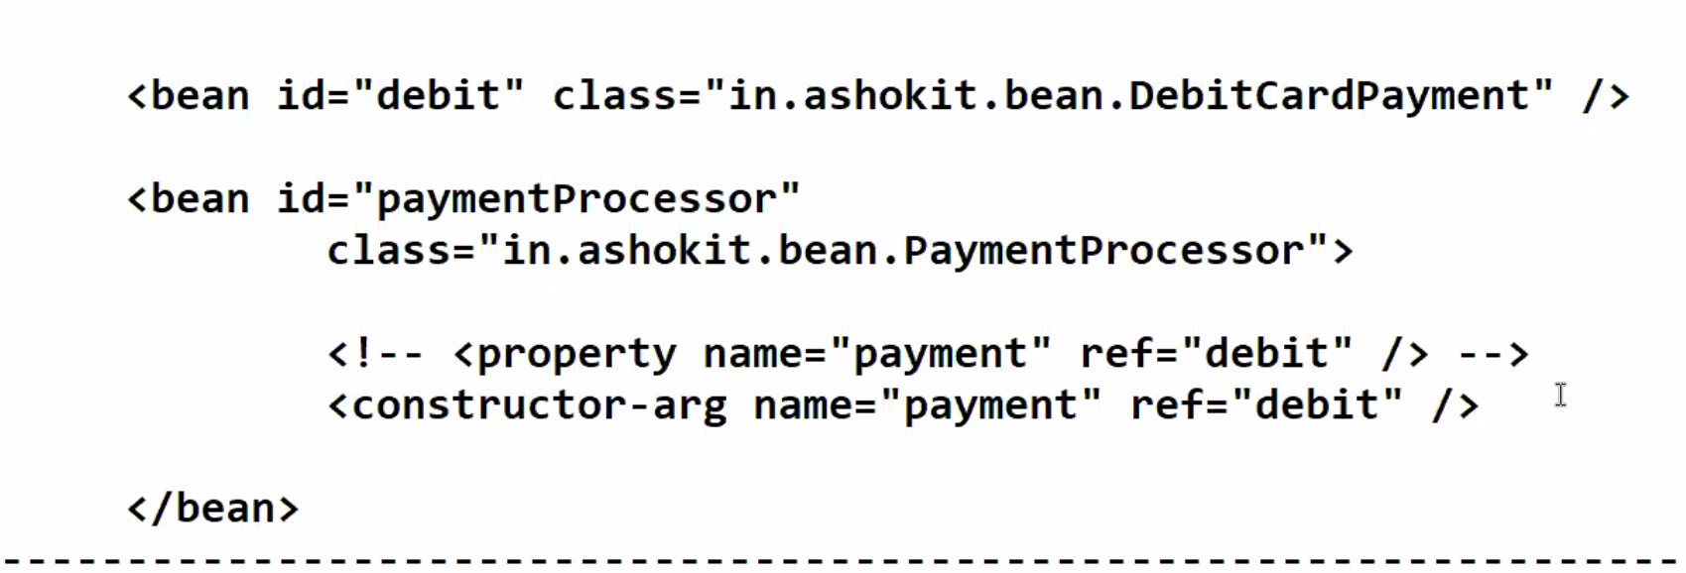

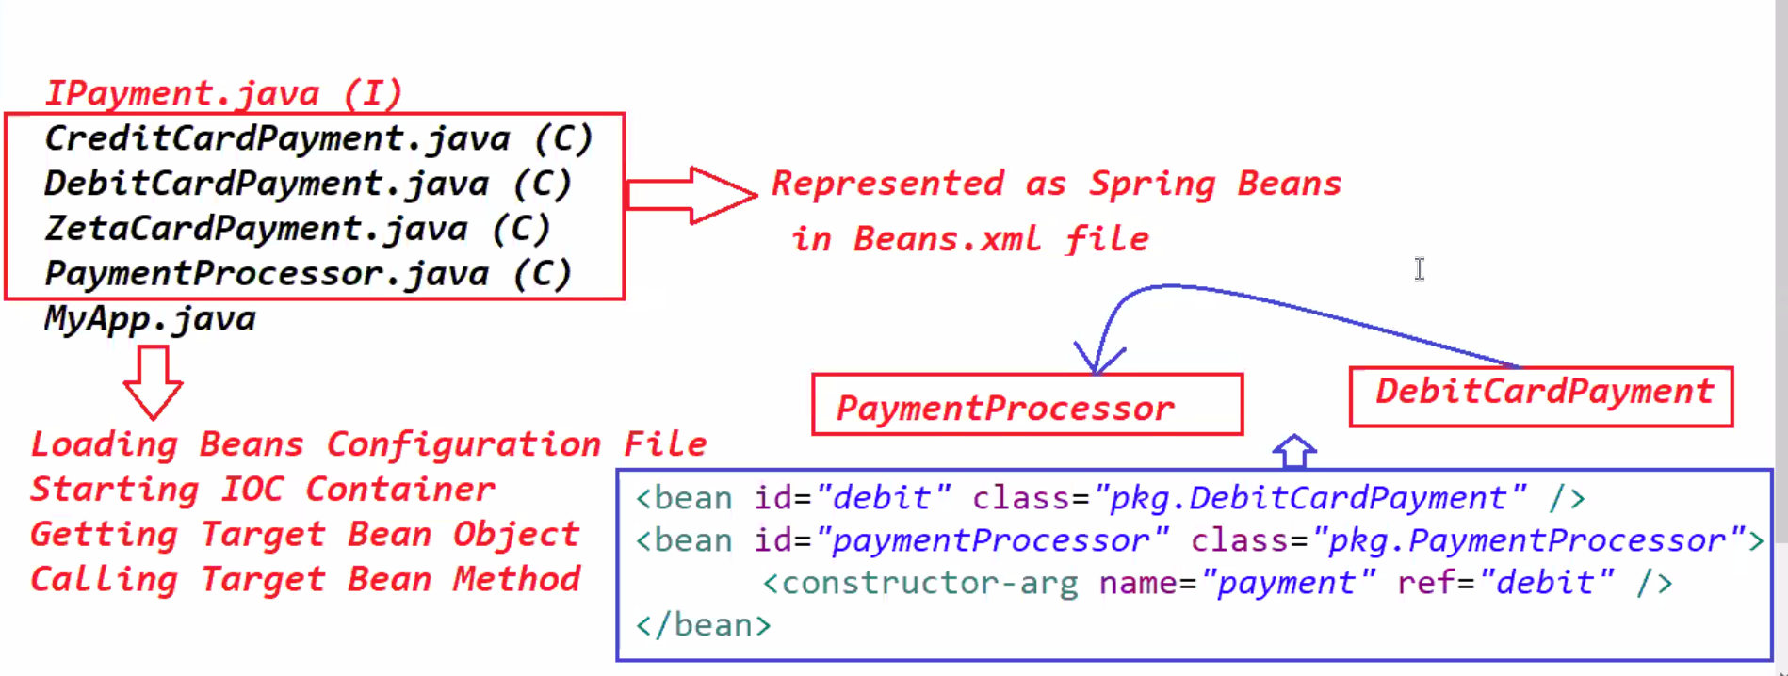

**24-Mar-2021**

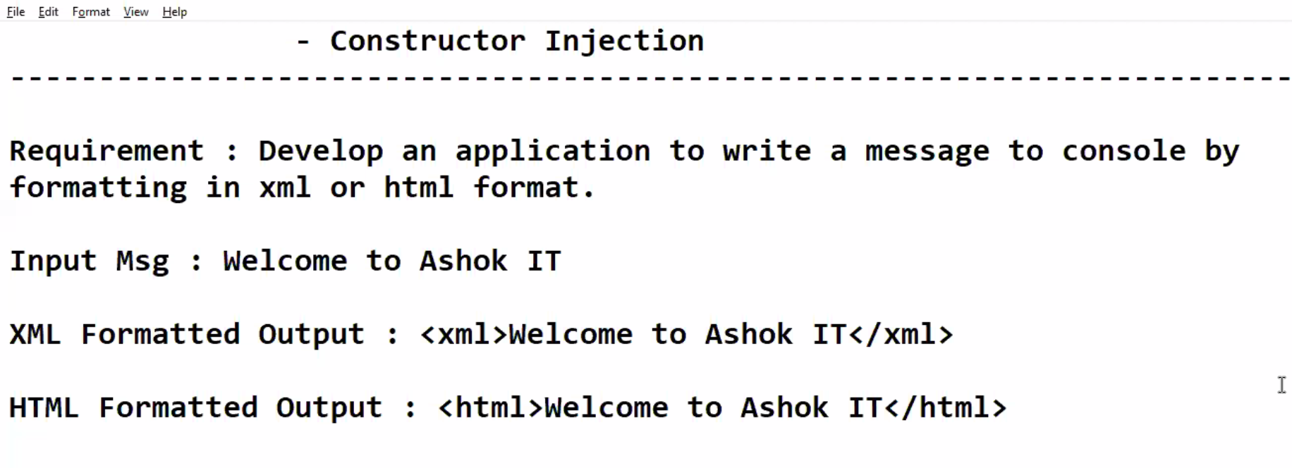

Develop an application to take the message and print in XML format and HTML format.

IMsgFormatter(I)

XmlMsgFormatter(C)

HtmlMsgFormatter(C)

MsgWriter(C)

MyApp class(C)

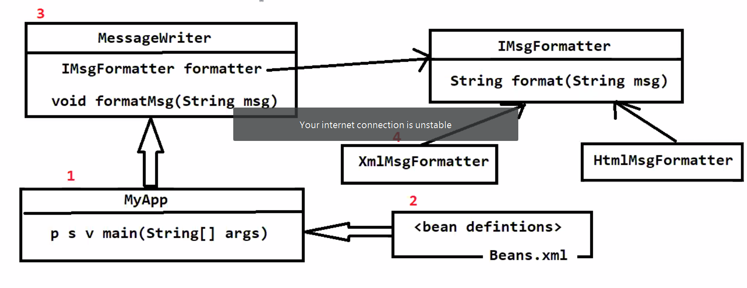

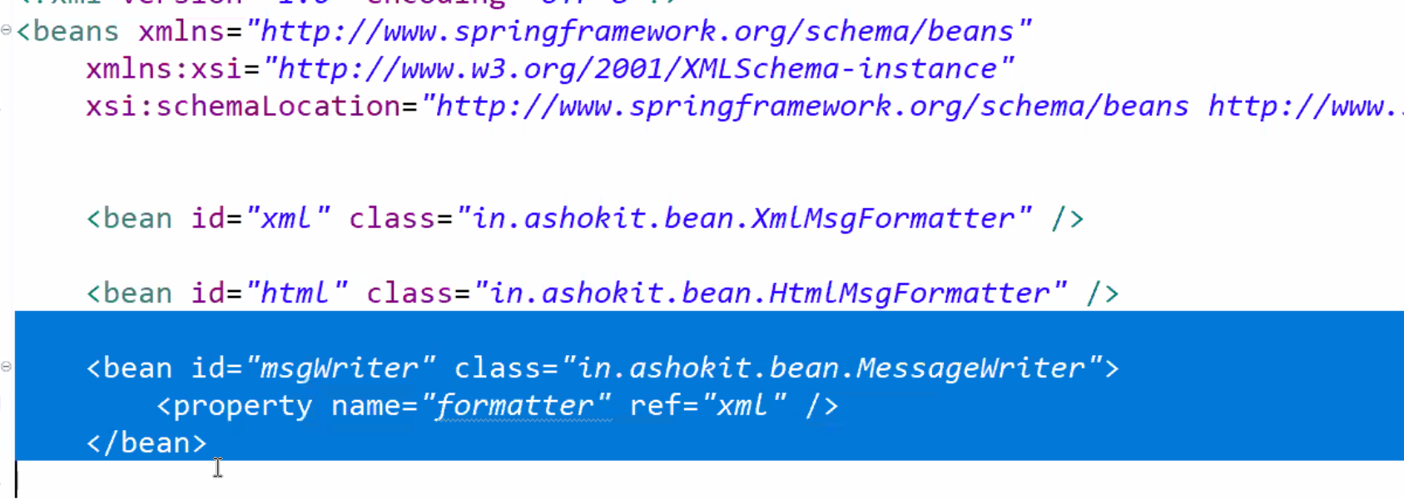

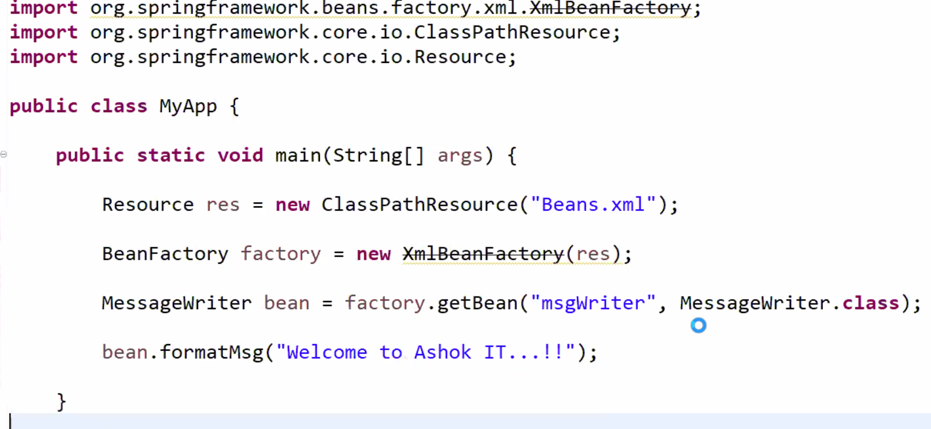

**25-Mar-2021**

We can start the IOC container in 2 ways.

1. Bean factory(I)
2. ApplicationContext([)

Resource res=new ClassPathResource(“Bean.xml”);

BeanFactory bean=new XmlBeanFactory(res);

BeanFactory bean= new BeanFactory(); //Invalid because its an Interface.

 ApplicationContext context = new ApplicationContext( ); //invalid

-> As BeanFactory and AppContext are interfaces we can't create object for them.

-> We need to create object for interfaces implementation classes.

ApplicationContext context=new ClassPathXmlAppContext(String loc);

So we need to create objects for the implemented classes of those interfaces.

Note: XmlBeanFactory got deprecated in Spring framework so it is not recommended to use.

-> All BeanFactory functionalities supported by ApplicationContext and AppContext providing additional benefits also which are not supported by BeanFactory.

1) Annotation Based Config Support

2) I18N Applications Support

3) Event Handling Support

-> BeanFactory follows Lazy loading mechanism (Until unless we call getBean() method it will not create object for bean class).

-> ApplicationContext follows Eager loading mechanism (At the time of startup only it will create objects for bean classes will keep them ready).

**26-Mar-2021**

How to Declare a java class as a spring bean?

We can declare by using <bean>

<bean id="" class="pkg.classname">

<property name=""  value="" or ref="" />

</bean>

<bean id=”student” class=”com.satti.Student”>

<property name=”id” value=”101” ref=”stdId”/>

</bean>

-> "value" attribute is used to value for primitives/wrapper classes directley

-> "ref" attribue is used to inject user-defined object

------------------------------------------------------------------------------

public class Address{

      private String city;

      private String state;

      private String country;

}

---------------------------------------------------------------------------

public class Person{

      private Integer personId;

      private String personName;

      private Address addr;

}

-----------------------------------------------------------------------------

<?xml version="1.0" encoding="UTF-8"?>

<beans xmlns="http://www.springframework.org/schema/beans"

xmlns:xsi="http://www.w3.org/2001/XMLSchema-instance"

xsi:schemaLocation="http://www.springframework.org/schema/beans http://www.springframework.org/schema/beans/spring-beans.xsd">

<bean id="address" class="in.ashokit.beans.Address">

<property name="city" value="Hyd" />

<property name="state" value="TG" />

<property name="country" value="India" />

</bean>

<bean id="person" class="in.ashokit.beans.Person">

<property name="personId" value="101" />

<property name="personName" value="Ashok" />

<property name="addr" ref="address" />

</bean>

</beans>

**Collection Injection**

----------------------------------------------------------------------------

package in.ashokit.beans;

import java.util.List;

import java.util.Map;

import java.util.Set;

public class Company {

private List<String> projects;

private Set<String> managers;

private Map<String, Double> salaries;

public List<String> getProjects() {

return projects;

}

public void setProjects(List<String> projects) {

this.projects = projects;

}

public Set<String> getManagers() {

return managers;

}

public void setManagers(Set<String> managers) {

this.managers = managers;

}

public Map<String, Double> getSalaries() {

return salaries;

}

public void setSalaries(Map<String, Double> salaries) {

this.salaries = salaries;

}

@Override

public String toString() {

return "Company [projects=" + projects + ", managers=" + managers + ", salaries=" + salaries + "]";

}

}

---------------------------------------------------------------------------------

<?xml version="1.0" encoding="UTF-8"?>

<beans xmlns="http://www.springframework.org/schema/beans"

xmlns:xsi="http://www.w3.org/2001/XMLSchema-instance"

xsi:schemaLocation="http://www.springframework.org/schema/beans http://www.springframework.org/schema/beans/spring-beans.xsd">

<bean id="company" class="in.ashokit.beans.Company">

<property name="projects">

<list>

<value>IES</value>

<value>HIS</value>

<value>CTP</value>

</list>

</property>

<property name="managers">

<set>

<value>Mr. Ramesh</value>

<value>Mr. Suresh</value>

</set>

</property>

<property name="salaries">

<map>

<entry key="Mr. Ramesh" value="85000.00" />

<entry key="Mr. Suresh" value="95000.00" />

</map>

</property>

</bean>

</beans>

**Start the IOC with the help of ApplicationContext:-**

ApplicationContext context=new ClassPathXmlApplicationContext(“beans.xml”);

Mobile mob=context.getBean(“mobile”, Mobile.class);

The process of injecting values into Collection type variable is called as Collection Injection.

**30-Mar-2021**

 If our variable type is List then IOC is creating ArrayList class object and injecting into List type variable.

-> If our variable type is Set then IOC is creating LinkedHashSet class object and injecting into Set type variable

-> If our variable type is Map then IOC is creating LinkedHashMap class object and injecting into Map type variable.

Q) Map and Properties both are supporting for Key-Value pair then when to use Map and when to use Properties?

Ans) If key-value both are strings then we can use Properties otherwise we can use Map.

private Properties roles;

<property name="roles">

<props>

<prop key="Ashok">Developer</prop>

<prop key="Sachin">Tester</prop>

</props>

</property>

**31-Mar-2021**

**Bean Scopes:-**

In Spring, IOC container will manage the dependencies among the classes in the Application.

We are configuring our class in configuration file.

Q) How many objects IOC will create for Spring Bean class?

-----------------------------------------------------------

Ans) IOC container will create only one object for spring bean because the default scope of spring bean is Singleton.

Q) How to create multiple objects for spring bean class?

----------------------------------------------------------

-> If we configure bean scope as "prototype" then IOC will create new object for every request.

Ex : <bean id="car" class="pkg.Car" scope="prototype"/>

 For singleton beans ApplicationContext will create objects at the time of IOC startup.

 If we configure scope as prototype until unless we call "getBean()" method ioc will not create object.

-> In bean tag scope attribute can take 4 values, they are

1) singleton

2) prototype

3) request

4) session

Note: Out of these 4 , request and session scopes will be used in Spring Web application development.

**Project Lombok**:- Main aim of the Project Lombok is to reduce the boiler plate code.

Need to download the project Lombok .jar file

@Data is used to get the Getters and Setters.

**Annotations of Project Lombok:-**

@Getter

@Setter

@GetterAndSetter

@EqualsAndHashCode

@NoArgConstructor

@Data

@CleanUp etc….

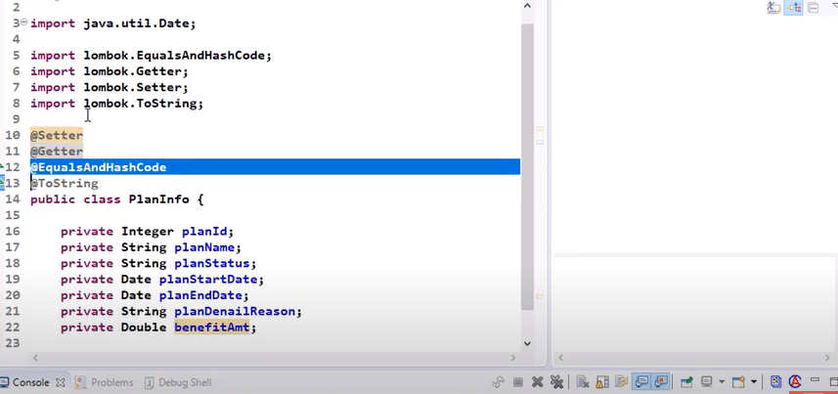

**01-April-2021**

Q) WHen to use singleton bean and when to use prototype bean?

-------------------------------------------------------------------------

-> In application we will have several classes to perform operation

-> In application some classes will have state and some classes will not have state.

**2-April-2021**

**Bean Inheritance:-**If we want to reuse the properties of one bean properties into another bean.

Object will be created at the time of Application started for Singleton Scope.

ApplicationContext ctx=new ClassPathXmlApplicaiotionContext(“Beans.xml”);

Mobile mobile=Ctx.getBean(“mobile”, Mobile.class);

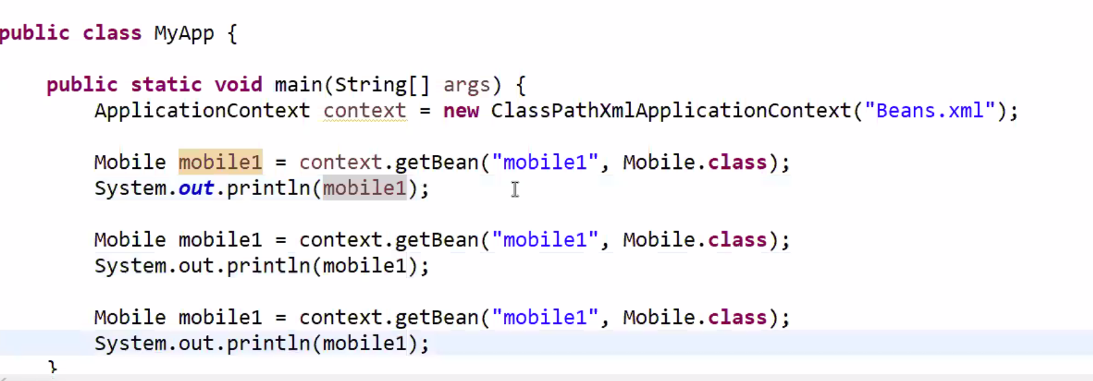

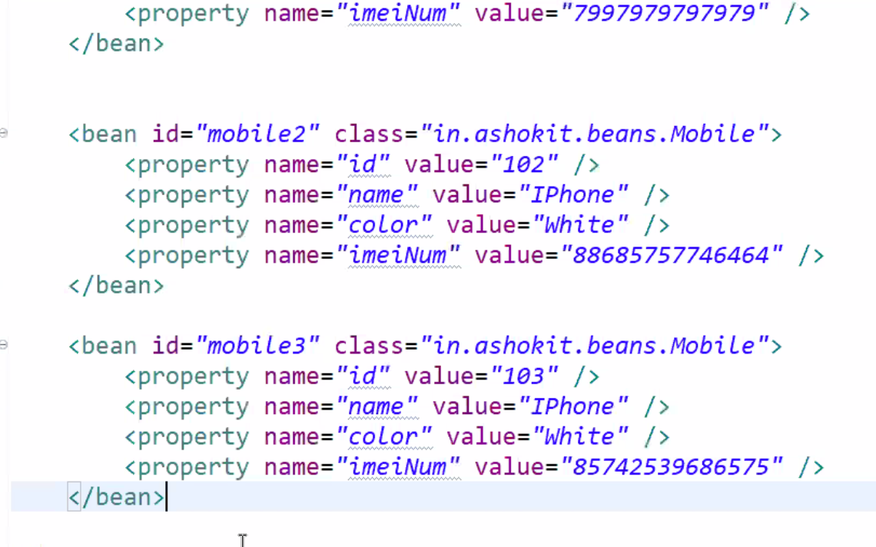

3 objects will be created because 3 instances are created. The scope singleton is applicable for Bean Definition.

Name and color is same for all the beans. I need to write 1000 times if I use 1000 beans.

Code redundancy is there

I can add parent in the bean property

<bean id=”mobile3” class=”in.AshokId.beans” parent=” baseMobile”>

<property name=”id” value=”101”/>

<property name=”imeiNum” value=”u99879879898”/>

</bean>

I can keep all the common properties and keep it in a separate bean.

<bean id=”baseMobile” class=”in.AshokId.beans” parent=”mobile1” abstract=”true”>

<property name=”id” value=”101”/>

<property name=”imeiNum” value=”u99879879898”/>

</bean>

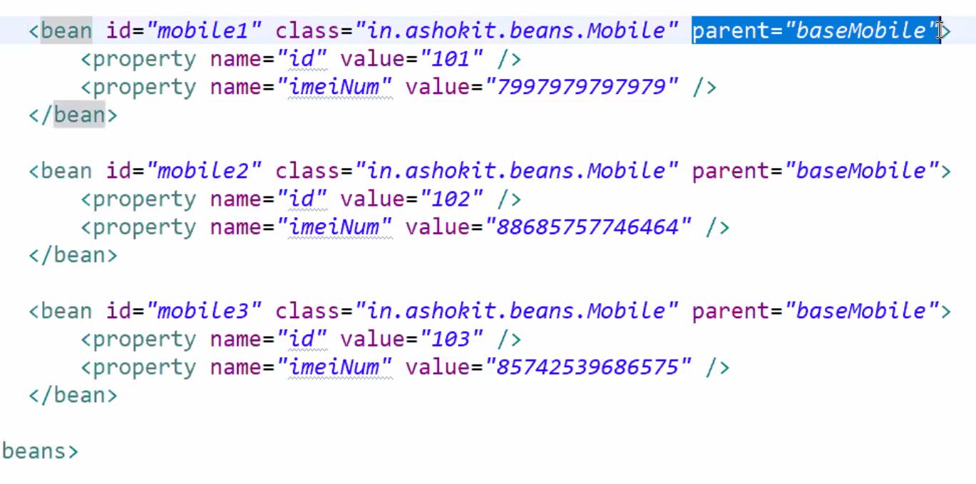

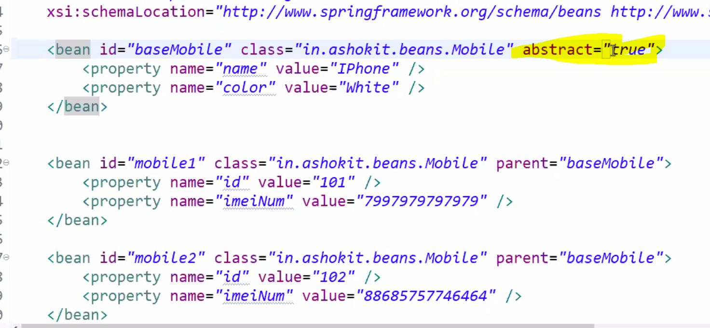

**06-Apr-2021**

**Collection Merging:-** The process of inheriting one bean collection properties into another bean collection is called Collection Merging.

<bean id="sm" class="in.ashokit.beans.Meeting">

<property name="meetingName" value="Scrum Meeting" />

<property name="participants">

<list>

<value>Ashok</value>

<value>Steve</value>

<value>Anil</value>

<value>Charan</value>

</list>

</property>

</bean>

<bean id="fm" class="in.ashokit.beans.Meeting">

<property name="meetingName" value="Functional Meeting" />

<property name="participants">

<list merge="true">

<value>Charles</value>

<value>Orlen</value>

</list>

</property>

</bean>

public class MyApp {

public static void main(String[] args) {

ApplicationContext context = new ClassPathXmlApplicationContext("Beans.xml");

Meeting scrum = context.getBean("sm", Meeting.class);

System.out.println(scrum);//steve, ashok, anil, charan

Meeting functional = context.getBean("fm", Meeting.class);

System.out.println(functional);//steve, ashok, anil, charan, charles, Orlen

}

}

**07-Apr-2021**

**Auto-Wiring**

In Application we will develop several classes below .

1. Controller
2. Service
3. Pojo
4. Repository(DAO)
5. Utility

One class is dependent on another class. In Spring IOC will manage the dependencies among the classes.

How IOC will understand the target and Dependent bean?

Programmer will configure the bean definitions in bean configuration based on that IOC will understand which is target and which is dependent.

Ex:

<bean id="addr" class="pkg.Address">

....

</bean>

<bean id="p" class="pkg.Person">

<property name="pid" value="101"/>

<property name="pname" value="Ashok"/>

<property name="address" ref="addr"/>

</bean>

 If we are injecting one bean into another bean using "ref" attribute then it is called as "Manual Wiring".

Spring framework provided IOC container having capability to identify what is target and what is dependent if we enable Autowiring (No need to write ref attribute).

-> We can enable autowiring using "autowire" attribute in target bean definition

-> "autowire" attribute having below modes

-> byType

-> byName

-> constructor

-> default

-> no

**08-Apr-2021**

In Spring framework we can inject one bean into another bean in 2 ways

1) Manual-wiring

2) Auto-wiring

"byType" means IOC will identify dependent bean based on Data Type of the variable.

-> Autowiring is applicable for "user-defined" dataype variables.

**09-Apr-2021**

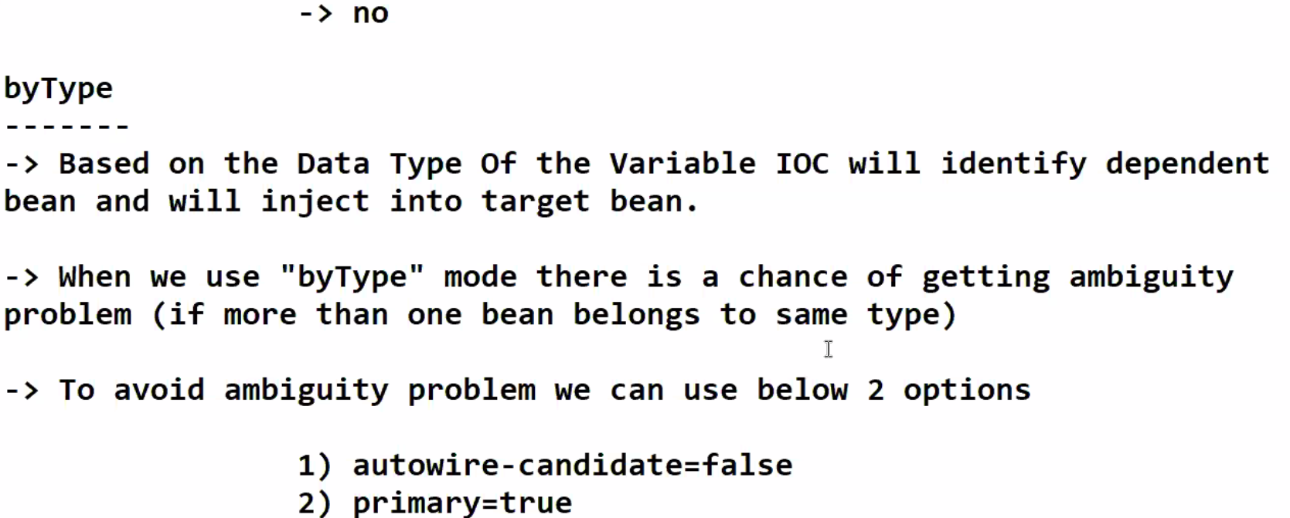

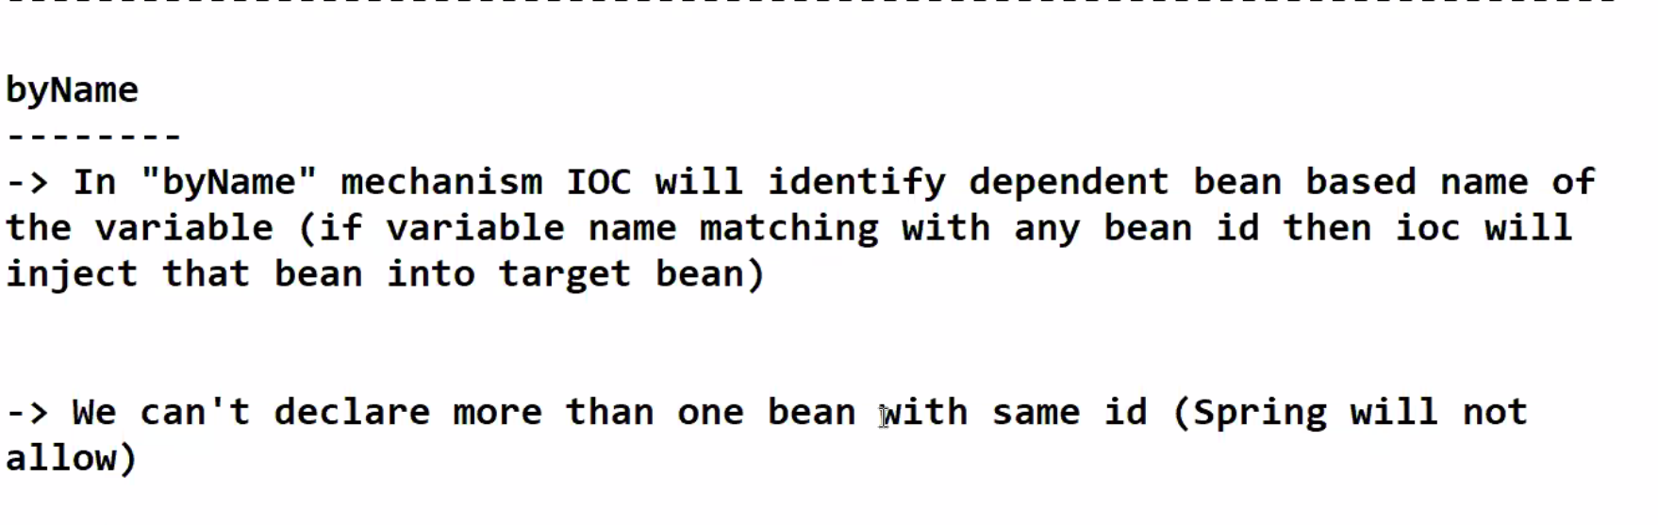

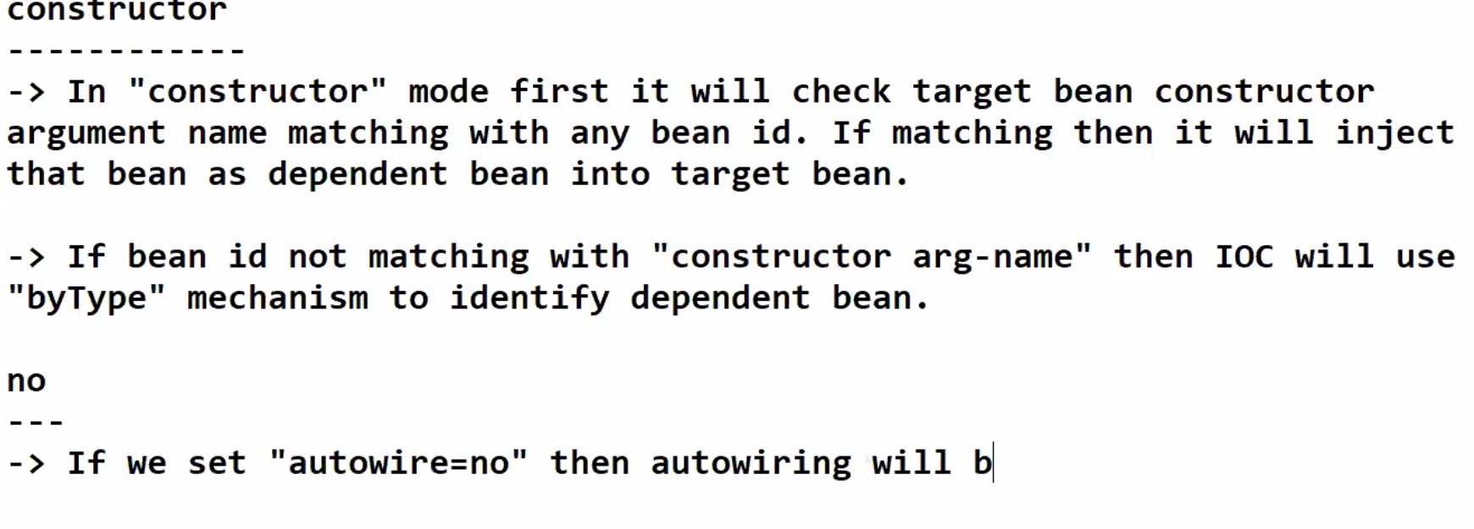

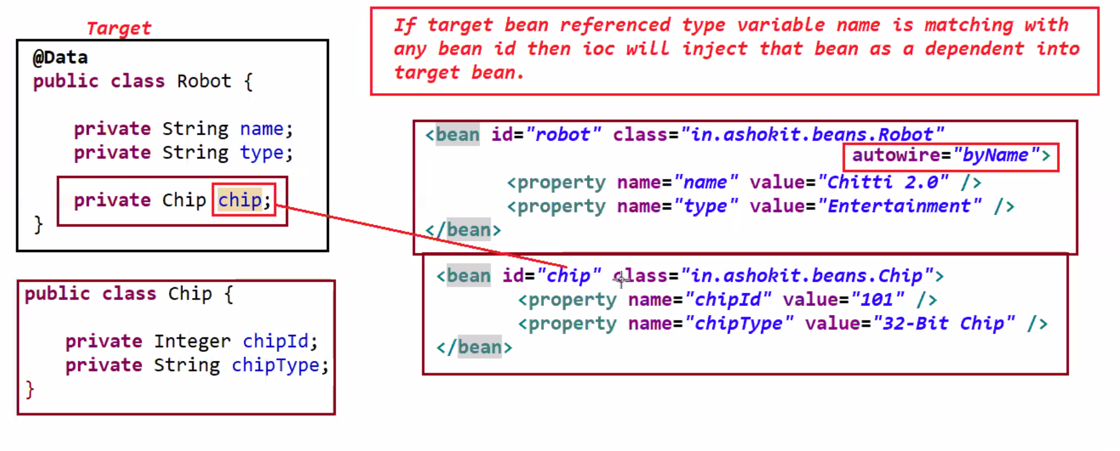

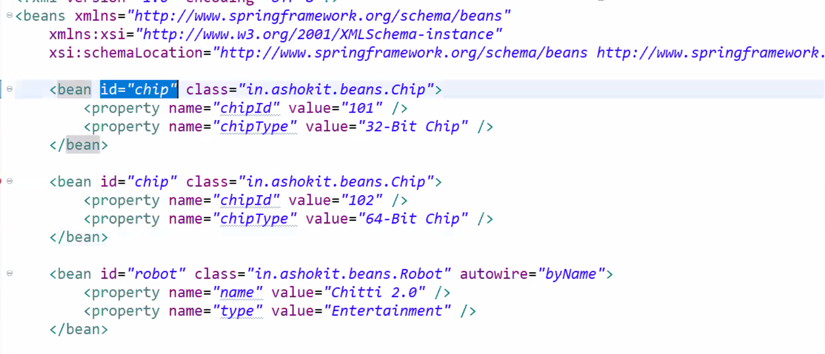

**12-Apr-2021**

**Spring Bean Life cycle:-**

Spring Bean has its life cycle. Bean life cycle will be managed by IOC container. Java life cycle will be managed by JVM. IOC is responsible for creating an destroying the objects.

We can use Spring Bean life cycle methods in 3 ways.

1. Programmatic approach
2. Declarative Approach (XML config)
3. Annotation based Approach.

Working with Bean life cycle (Programmatic approach):

1. To work with Bean Life cycle we need to use 2 interfaces.
2. Initializing Bean
3. Disposable

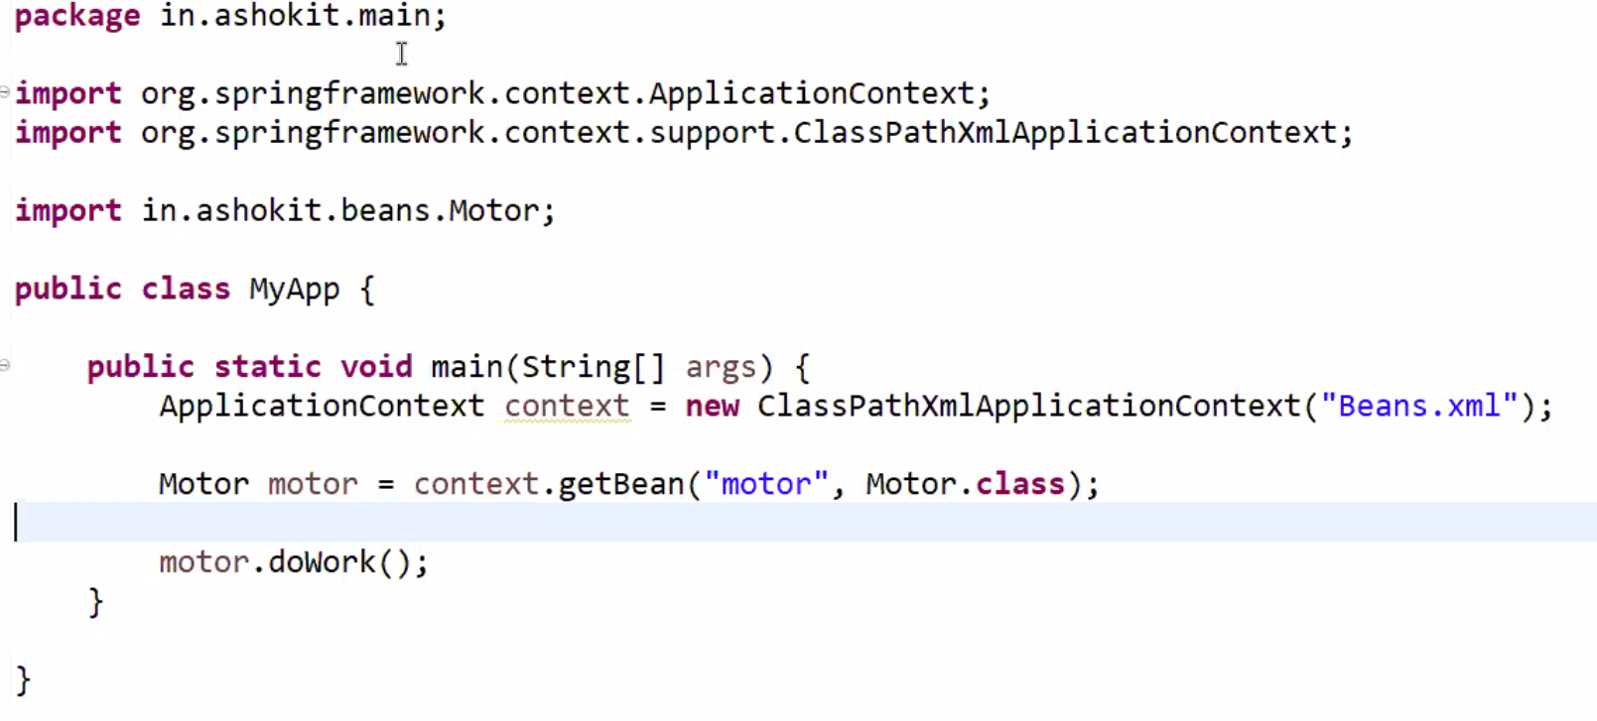

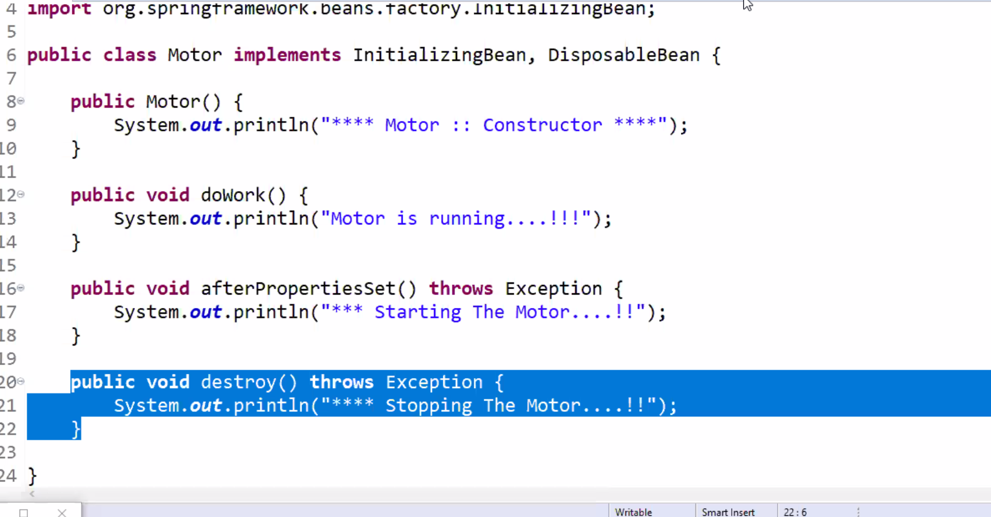

Where to use the Bean life cycle in Realtime?

If we want to perfom any operation post bean initialization and pre-bean-destroy. We will use the Bean life cycle. Connection pool.

